**Pages 14-26 in *Programming A Comprehensive Introduction***

**Section 1: Key Attributes of Object-Oriented Programming**

Encapsulation- the packing of data and functions into a single component. The features of **encapsulation** are supported using classes in most object-oriented programming languages, although other alternatives also exist.

public- Java keyword which declares a member's access as public. Public members are visible to all other classes. This means that any other class can access a public field or method. Further, other classes can modify public fields unless the field is declared as final.

private- a Java keyword which declares a member's access as private. That is, the member is only visible within the class, not from any other class (including subclasses). The visibility of private members extends to nested classes.

access modifier- are keywords used to specify the declared accessibility of a member or a type. This section introduces the four access modifiers: public, protected, internal, private

Class- A class can be defined as a template/blue print that describes the behaviors/states that object of its type support.

Object-  Objects have states and behaviors. Example: A dog has states - color, name, breed as well as behaviors -wagging, barking, eating. An object is an instance of a class.

Method-  collection of statements that are grouped together to perform an operation. When you call the System.out.println method, for example, the system actually executes several statements in order to display a message on the console.

Polymorphism – (Brief in own words) It’s one of the way that an object change to different form. It could also inherited from a parent class to a child class.

Java key words (give 5 examples) – class, break, assert, catch, const

**Section 2: WRITING POGRAMS**

**main () –** starting point for the execution of the code in the application

**static-** methods that do not need to access to an object's state or only use static fields

**void-** keyword denotes that a method does not have a return type

Variable (var)-  container that holds values that are used in a Java program

Instance variables- variable defined in a class (i.e. a member variable), for which each instantiated object of the class has a separate copy, or instance. An instance variable is similar to and contrasts with a class variable

interger (**int**)- the whole number data type returned by the function

**double** – the decimal data type returned by the function.

How does **double** differ from **int**-

Double will return a decimal while int will return a whole number.

In order to return a double, everything must also be decimal type.

Symbol ( + ) in java programming basic arithmetic- addition

Symbol ( * ) in java programming basic arithmetic- multiplication

Symbol ( - ) in java programming basic arithmetic- subtraction

Symbol ( / ) in java programming basic arithmetic- division

Symbol ( = ) in java programming basic arithmetic- assignment

The Difference between the method **System.out.println** and **System.out.print**-

Println will go to the next line after it finish the printing while print only stay on the same line.

Explain How “+” is used within a System.out.println method-

**The + symbol can connect the string and the variable**

**For example, System.out.println(“something” + variable);**

**Section 3: Identify Syntax Errors – Write correct next to incorrect statements and highlight difference**

Public static void main(String[] args) - public static void mainString args) {

system.out.println(‘’ ‘’); - System.out.println(“ “);

System.out.print(“ “) – System.out.print(“ “);

**Programming Assignment Due 1/29/15**

You have two programs to complete for today’s programming task.

**1st  Task–**

Write a program where you declare 4 different variables that add up 100, with the program auto-calculating the 5th variable / integer which is 100..

Print output with:

Var1 is “integer”, Var 2 is “integer”, Var 3 is “integer”, Var 4 is “integer” // all numbers on Same Line

(Blank Line)

var1 + var2 + var3 + var4 = var5 (equal to 100)

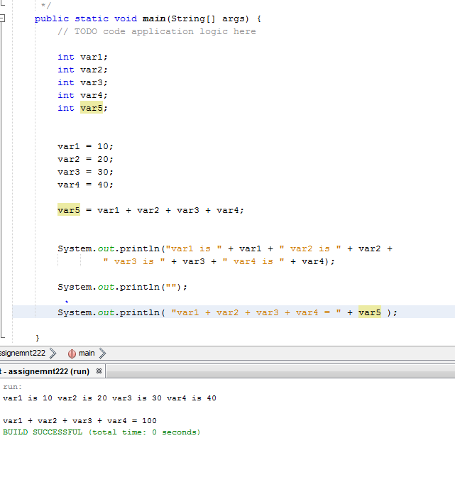

**2st  Task–**

Page 39. **in *Programming A Comprehensive Introduction***

**#13.** The moon’s gravity is about 17 percent that of the earth’s. (Meaning you weigh less on the moon). Write a program that computes your affective weight on the moon.

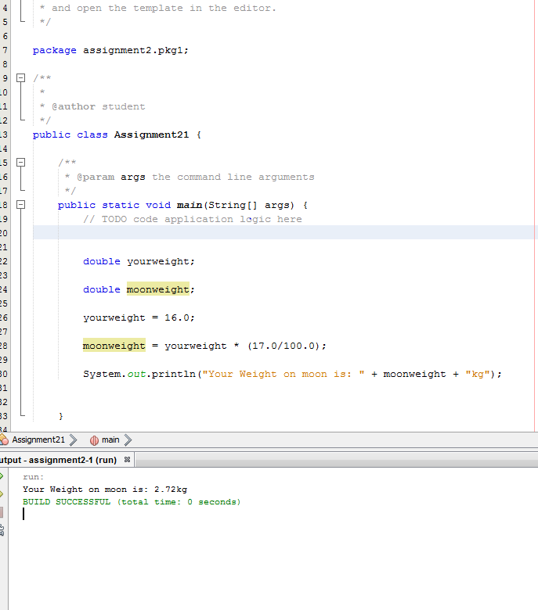

Once you have completed your Program attach a picture of your program to this assignment and submit using your flash drive during lab-time.